**MONGODB Task**

* Created all the given collections under zenclass db

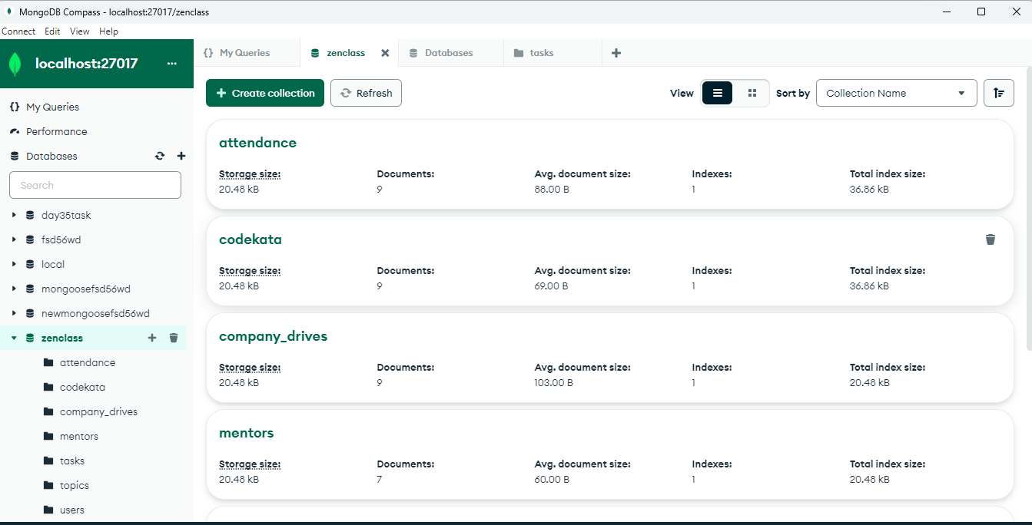

1. Find all the topics and tasks which are thought in the month of October

db.tasks.find({

$and : [{taught_on : {$gt : ISODate("2020-10-01T00:00:00.000Z") }},

{taught_on : {$lt : ISODate("2020-11-01T00:00:00.000Z") }}]

})

1. Find all the company drives which appeared between 15 oct-2020 and 31-oct-2020

db.company_drives.find({

$and : [{drive_date : {$gte : ISODate("2020-10-15T00:00:00.000Z") }},

{drive_date : {$lte : ISODate("2020-10-30T00:00:00.000Z") }}]

})

1. Find all the company drives and students who are appeared for the placement.

db.company_drives.find({is_appeared:true})

1. Find the number of problems solved by the user in codekata

db.codekata.find()

1. Find all the mentors with who has the mentee's count more than 15

db.mentors.find({mentee_count : {$gt : 15}},{mentorName:1,_id:0})

1. Find the number of users who are absent and task is not submitted  between 15 oct-2020 and 31-oct-2020

db.users.find({

$and : [{attendance :"absent"},{isTaskSubmitted:false},

{submission_date : {$gte : ISODate("2020-10-15T00:00:00.000Z") }},

{submission_date : {$lte : ISODate("2020-10-30T00:00:00.000Z") }}]

})